What types of ‘SMARTS’ do you have?

[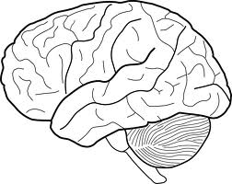](http://www.google.com/url?sa=i&source=images&cd=&cad=rja&docid=IzzCY3KADguc1M&tbnid=VKPM12aBWVqmrM&ved=0CAgQjRw&url=http://www.clker.com/clipart-outline-of-brain.html&ei=QA7UUpHmN-ezsQTahIH4Cw&psig=AFQjCNH6cQrTO_eHbzyxV2pVEDpWjVz_kA&ust=1389715393002843)

**Draw a picture of ONE thing that you are good at:**

|  |
| --- |
|  |