BEING TOO NOSY LIKE MR. NOSEY?

[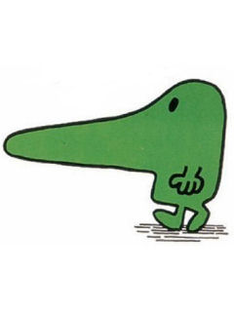](http://www.google.com/url?sa=i&rct=j&q=&esrc=s&frm=1&source=images&cd=&cad=rja&docid=0eABIUcDQQzXzM&tbnid=nIWKJA120UvLnM:&ved=0CAUQjRw&url=http%3A%2F%2Fwww.umnet.com%2Ffree-screensaver%2F53024-Mr_Nosey_240x320&ei=l3giUaCjNIuD0QHznoCYAg&bvm=bv.42553238,d.dmQ&psig=AFQjCNGEmtJUNDb-EfgQ1RrL7N6XC0pWuQ&ust=1361299970388939)

-If a problem or situation has NOTHING to do with you…stay out of it!

-If a teacher or student wants to tell you something important…they will!

-Friends and teachers do NOT like when you are too nosy!

**WRITE OR DRAW A PICTURE OF WHEN YOU WERE TOO NOSY**

|  |
| --- |
|  |

KEEP YOUR [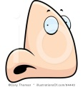](http://www.google.com/url?sa=i&rct=j&q=&esrc=s&frm=1&source=images&cd=&cad=rja&docid=V0dGygGldrlnkM&tbnid=9hPd1ncUPZZgRM:&ved=0CAUQjRw&url=http%3A%2F%2Fwww.illustrationsof.com%2F94443-royalty-free-nose-clipart-illustration&ei=7HYiUf-7OIzV0gGXsYDgBw&bvm=bv.42553238,d.dmQ&psig=AFQjCNGdrJskmvXa6VpK6g2BRdyfnKX_-A&ust=1361299530674032) IN YOUR **OWN** BUSINESS!